# ELEVATING SUPERMARKET PROFITABILITY BY OPTIMIZING SALES AND INVENTORY DATA

## Mid Term Report for the BDM Capstone Project

Submitted by

Name: Preethu Johnson Roll number:22f1001747



IITM Online BS Degree Program,

Indian Institute of Technology, Madras, Chennai Tamil Nadu, India, 600036

# Contents

1. Executive Summary and Title 2
2. Proof of Originality of Data 2
3. Meta Data and Descriptive Statistics 5
4. Detailed Explanation of Analysis Process/Method 9

6 Results and Findings 10

# Executive Summary and Title

### Title: Elevating Supermarket Profitability by Optimizing Sales and Inventory Data

### Minnus Super Store, a prominent B2C supermarket located in Thrissur district, Kerala, is currently undergoing a transformative project aimed at enhancing profitability through improved sales and inventory management. Over the past few months, the store has been experiencing operational inefficiencies, such as suboptimal stock levels and inconsistent sales patterns, leading to missed revenue opportunities and increased costs.

### This project focuses on leveraging data-driven strategies to identify key areas for improvement. With over 20,000 sales transactions collected over a seven-month period, this analysis aims to uncover patterns in product demand, inventory turnover, and sales trends. The goal is to use these insights to streamline operations, ensure better stock management, and enhance overall profitability.

### The analysis will address critical issues, such as identifying high-demand products that should be prioritized in inventory, minimizing stockouts and overstocking, and implementing pricing strategies that align with market trends. By understanding customer purchase behavior, the store can also introduce targeted promotions and bundling strategies that improve customer satisfaction and retention.

### Using advanced data analytics tools, the project will offer actionable insights and recommendations for optimizing the store’s sales and inventory processes. The findings will guide the store in making informed decisions to improve operational efficiency, boost profitability, and ensure sustained growth.

### The expected outcome of this project is a significant increase in operational efficiency, reduced costs associated with poor inventory management, and improved customer retention, ultimately driving profitability and business expansion.

### 

# Proof of originality of the Data

**Details of the Business**

Name or the Business: Minnus Super Store

Name of the Owner: Kannan K P

Place of the Business: Kadavallur, Thrissur, Kerala

Starting Year of the Business: 2010

Shop Renovated Year: 2021

Operating Hours of the Business: 8 am to 10 pm (14 hours/day)

Turn Over of the Business: ~10,000/day

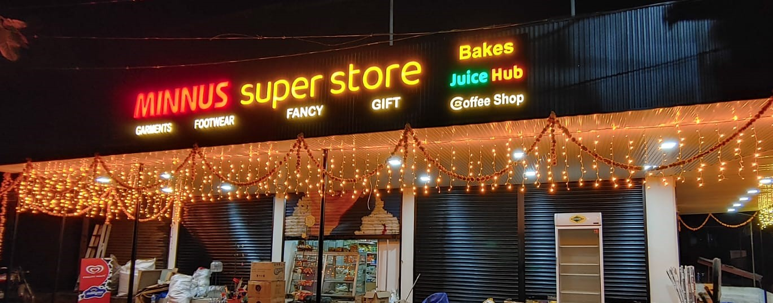

**Picture 1:** Image of the Minnus Super Store

**Picture 2:** Receipt of Bill at the Store

**Picture 3:** Authorization Letter from the Minnus Super Store

### 

### Link to the Meeting with the Owner:

### <https://drive.google.com/file/d/1vU62bEr1ddyuaKr-WyOvR5VoiBbCY5tz/view?usp=drive_link>

**Link to the Data Collected**:

<https://docs.google.com/spreadsheets/d/1OhR-XDatmofj98iaMFNMEZLkujDjXXtq/edit?usp=sharing&ouid=106796579137076179815&rtpof=true&sd=true>

1. **Metadata and Descriptive Statistics**

I had collected the data of past 7 months from the Minnus Super Store. The data available was in the form of invoice bills. It was unorganized data. The data had the following details:

* Description of the product
* Quantity of the products sold
* Unit Weighing of the product (KG, No. of Pieces)
* Rate of the product sold
* Net amount of the product sold
* Date
* Invoice Number
* Sub Total
* Day Total
* Net Total

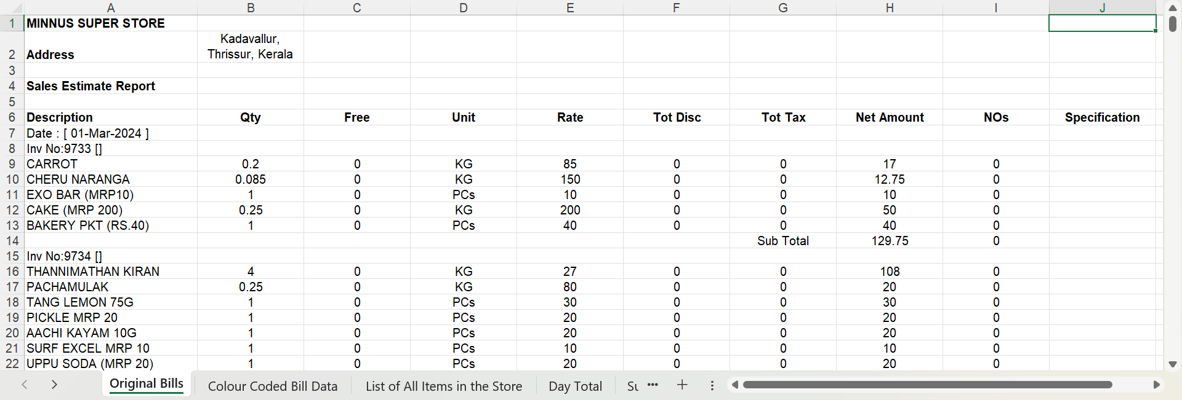

**Picture 4:** Raw Bills Data of the Store

The first step in my data cleaning process was to organize the obtained data into a table format. Identify the list of items sold in the store, the total purchase happened in a day and a month. I segregated the products sold into different categories to analyze the revenue contribution from each category.

The problems faced by the business was the following and my analysis started to address these issues:

1. **Fluctuating Sales Despite Expansion**: Although the store has increased its product range and expanded its capacity to attract a broader customer base, sales have remained inconsistent, showing no significant improvement in revenue stability.
2. **Challenges in Inventory Management**: The store struggles with effective inventory control, often leading to two critical issues—either excess stock that results in wastage or insufficient stock levels that lead to stockouts and missed sales opportunities.
3. **Revenue Volatility Due to Seasonal Demand**: Sales are heavily influenced by external factors such as seasonal shifts, festivals, and local events. This variability makes it difficult to maintain a steady revenue stream throughout the year, creating instability in business performance.

I sorted the data into different ways to analyze the problems defined.

* I segregated the day totals of sales to know the trend of sales over the days of a week in the past seven months.
* Then I sorted the data by the total sales over the month to see the fluctuations of sales in different months.
* I sorted the products into different categories using color coding to sort the data from excel to see the category wise sales over the months.

**Picture 5:** Color Coded the Data Manually for Easy Sorting to Categories

# Detailed Explanation of Analysis Process/Method:

The process involved in analyzing the sales data from Minnus Super Store was carefully designed to address specific business challenges identified during the initial stage of the project. The method I employed is a combination of **Data Cleaning**, **Categorical Segmentation**, and **Trend Analysis**. This approach was selected based on the type and structure of the data available and the business problems faced. The sorting and segregation cannot be done so easily in any other platforms than excel, so MS Excel was an obvious choice.

1. **Data Cleaning and Structuring**: The initial dataset was in the form of unorganized invoice bills, containing various attributes like product description, quantity sold, unit weighing, rate, and total sales. My first step was to clean and organize the data into a structured table format. This allowed me to standardize the input, making it easier to analyze and sort the information. This method is essential for handling raw data, as it eliminates inconsistencies and makes the dataset ready for meaningful analysis.
   * **Justification**: Without proper data structuring, it would have been nearly impossible to derive any actionable insights. Organizing the data laid the foundation for all subsequent analysis steps. The structured approach ensures that each product and its associated sales information is readily available for any sorting or filtering.
2. **Categorical Segmentation**: Once the data was structured, the next step was to categorize the products sold at the store. This segmentation was done based on logical groupings like food items, beverages, personal care, etc. By doing this, I was able to analyze the contribution of each category to the total revenue and identify which categories were more profitable or had fluctuating demand.
   * **Justification**: Segregating products into categories helps break down the data into manageable sections, which is critical for understanding revenue contributions from different parts of the business. This method is particularly effective in identifying trends and pinpointing specific areas of concern, such as categories with high stockouts or high returns.
3. **Trend Analysis**: After organizing the data into categories, I conducted a trend analysis by examining daily and monthly sales totals. This helped identify fluctuations in sales patterns over time, revealing trends like increased sales on weekends or seasonal spikes. This method is crucial in understanding the external factors affecting sales, such as festive seasons or local events.
   * **Justification**: Trend analysis offers a clear picture of the temporal variations in sales and helps in predicting future patterns. Given the store's challenge of fluctuating sales despite expansion, this method was appropriate to track the effectiveness of new product introductions and other strategies. It is a widely accepted approach for businesses that experience seasonality and irregular demand.
4. **Manual Color Coding for Sorting**: To further streamline the process, I used color coding in Excel to visually differentiate between categories. This made it easier to sort and analyze category-specific performance across months.
   * **Justification**: Manual sorting and color coding provided a visual aid for quick identification of trends and anomalies. This method, though simple, is highly effective in large datasets where multiple categories are involved, making it an appropriate choice for this analysis.

# Results and Findings

After segregating and sorting the data into meaningful data sets, I generated different graphs for a better understanding of the scenario and visual clarity.

I analyzed the structured data and found out that there has been considerable fluctuation in the sales of the products over the months and it is affected by the seasonal demands.

**Picture 6**: Bar Chart: The variation in the sales on the days of the week over the period

**Picture 7:** Bar Chart: The variation in the sales in the past 7 months

The months, April and August have the highest sales contributing to Vishu and Onam festivals, authentic seasonal festivals in Kerala. The sales attained a very heavy boost during those months whereas other months couldn’t catch up with that pace.

The following pie chart shows the contribution of each category to the total revenue:

**Picture 8:** Pie Chart: The Category Revenue Contribution

It was visible from the data that the different categories generate different margins of profit. The following chart shows the profits generated by each category:

**Picture 9:** Combination Chart: Profit Generation for each Category

As expected, beauty and cosmetic products generate higher margins of profit. Then comes personal care items. Grains and staples generate the least profit, even though they create the highest revenue.